**GROUP NAME: BUTTERFLY**

|  |  |
| --- | --- |
| **NAME** | **ID** |
| **AHMED, RAIHAN** | **19-40978-2** |
| **OSMAN, SUPRIYA** | **19-39735-1** |
| **MANNI, NAHIN AFRIN** | **18-38734-3** |
| **LEO, NAFINUR** | **20-42195-1** |
| **RAHE, TASIN HASAN** | **19-41008-2** |

**Title:** **Hospital Management System**

A patient can be admitted in a ward at ‘X’ hospital, this process can be handled by **Hospital Management System**. A patient is identified by the patient id. At the system also stores patient name, ward number, mobile number, age, date of birth, gender and address. Employee can work in wards. A ward is identified by ward number. Ward type and ward section are also stored. At least one employee must work in a ward. Patient gives payment which contains amount, date and identified by payment number. Employee of hospital treats patient and works in ward. To identify an employee the system stores employee id along with name, sector, post, salary, ward section, ward number and department. An employee name is composed of first name and last name. The entire employee belongs to a department which is identified by department number. Each department should have at least one employee. The system also stores department name, laboratory number and location. Department has a laboratory that identified by laboratory number and it also has laboratory type. Laboratory is fully dependent on department. Employee earns salary. Every employee’s salary is identified by salary grade. Salary also contains highest and lowest salary. Account receives payment from patients as well as employee gets salary from account. Account number is main identification of account which also contains account type, amount and add/less.

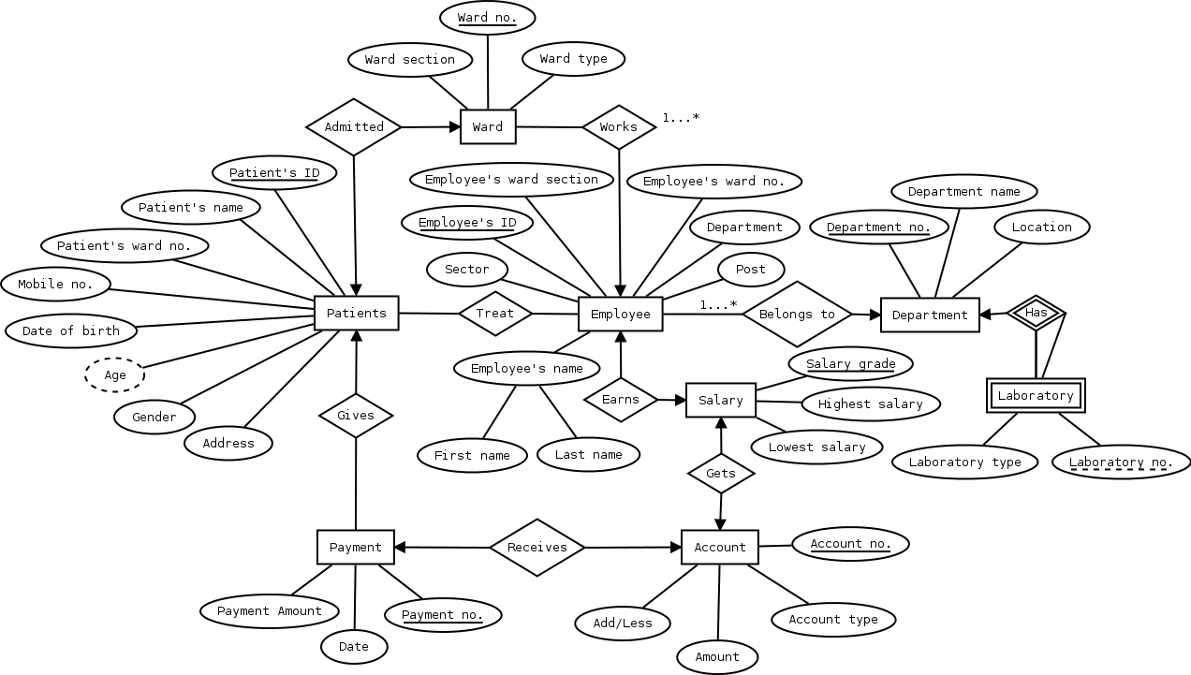

**Normalization**

**Belongs to:**

UNF: 1st: First name, Last name, Sector, Employee’s ID, Post, Employee’s ward no., Employee’s ward section, Department, Department no., Department name, Location.

1NF: 1st: First name, Last name, Sector, Employee’s ID, Post, Employee’s ward no., Employee’s ward section, Department, Department no., Department name, Location.

2NF: 1st: Employee’s ID, Employee’s name, First name, Last name, Post, Sector, Employee’s ward no., Employee’s ward section, Department

2NF: 2nd: Department no., Department name, Location.

2NF: 3rd: Department no., Department no.

3NF: 1st: Employee’s ID, Employee’s name, First name, Last name, Post, Sector, Employee’s ward no., Employee’s ward section, Department

3NF: 2nd: Department no., Department name, Location.

3NF: 3rd: Department no., Department no.

**HAS:**

UNF: 1st: Department no., Department name, Location, Laboratory type, Laboratory no.

1NF: 1st: Department no., Department name, Location, Laboratory type, Laboratory no.

2NF: 1st: Department no., Department name, Location.

2NF: 2nd: Laboratory no., Laboratory type.

2NF: 3rd: Department no., Laboratory no.

3NF: 1st: Department no., Department name, Location.

3NF: 2nd: Laboratory no., Laboratory type.

3NF: 3rd: Department no., Laboratory no.

**Earns:**

UNF: 1st: Employee’s ID, Post, Sector, First name, Last name, Employee’s ward no., Employee’s ward section, Department, Salary grade, Highest salary, Lowest salary.

1NF: 1st: Employee’s ID, Post, Sector, First name, Last name, Employee’s ward no., Employee’s ward section, Department, Salary grade, Highest salary, Lowest salary.

2NF: 1st: Employee’s ID, Post, Sector, First name, Last name, Employee’s ward no., Employee’s ward section.

2NF: 2nd: Salary grade, Highest salary, Lowest salary.

2NF: 3rd: Employee’s ID, Salary grade.

3NF: 1st: Employee’s ID, Post, Sector, First name, Last name, Employee’s ward no., Employee’s ward section.

3NF: 2nd: Salary grade, Highest salary, Lowest salary.

3NF: 3rd: Employee’s ID, Salary grade.

**Works:**

UNF: 1st: Employee’s ID, First name, Last name, Sector, Post, Department, Employee’s ward no., Employee’s ward section, Ward section, Ward type, Ward no.

1NF: 1st: Employee’s ID, First name, Last name, Sector, Post, Department, Employee’s ward no., Employee’s ward section, Ward section, Ward type, Ward no.

2NF: 1st: Employee’s ID, First name, Last name, Sector, Post, Employee’s ward section, Employee’s ward no.

2NF: 2nd: Ward no., Ward type, Ward section.

2NF: 3rd: Employee’s ID, Ward no.

3NF: 1st: Employee’s ID, First name, Last name, Sector, Post, Employee’s ward section, Employee’s ward no.

3NF: 2nd: Ward no., Ward type, Ward section.

3NF: 3rd: Employee’s ID, Ward no.

**Treat:**

UNF: 1st: Employee’s ID, Employee’s ward section, Employee’s ward no., First name, Last name, Department, Post, Sector, Patient’s ID, Patient’s name, Patient’s ward no., Mobile no., Date of birth, Age, Gender, Address.

1NF: 1st: Employee’s ID, Employee’s ward section, Employee’s ward no., First name, Last name, Department, Post, Sector, Patient’s ID, Patient’s name, Patient’s ward no., Mobile no., Date of birth, Age, Gender, Address.

2NF: 1st: Employee’s ID, Employee’s ward section, Employee’s ward no., First name, Last name, Department, Post, Sector.

2NF: 2nd: Patient’s ID, Patient’s name, Patient’s ward no., Mobile no., Date of birth, Age, Gender, Address.

2NF: 3rd: Employee’s ID, Patient’s ID.

3NF: 1st: Employee’s ID, Employee’s ward section, Employee’s ward no., First name, Last name, Department, Post, Sector.

3NF: 2nd: Patient’s ID, Patient’s name, Patient’s ward no., Mobile no., Date of birth, Age, Gender, Address.

3NF: 3rd: Employee’s ID, Patient’s ID.

**Admitted:**

UNF: 1st: Patient’s ID, Patient’s name, Patient’s ward no., Mobile no., Date of birth, Age, Gender, Address, Ward no., Ward section, Ward type.

1NF: 1st: Patient’s ID, Patient’s name, Patient’s ward no., Mobile no., Date of birth, Age, Gender, Address, Ward no., Ward section, Ward type.

2NF: 1st: Patient’s ID, Patient’s name, Patient’s ward no., Mobile no., Date of birth, Age, Gender, Address.

2NF: 2nd: Ward no., Ward section, Ward type.

2NF: 3rd: Patient’s ID, Ward no.

3NF: 1st: Patient’s ID, Patient’s name, Patient’s ward no., Mobile no., Date of birth, Age, Gender, Address.

3NF: 2nd: Ward no., Ward section, Ward type.

3NF: 3rd: Patient’s ID, Ward no.

**Gives:**

UNF: 1st: Patient’s ID, Patient’s name, Patient’s ward no., Mobile no., Date of birth, Age, Gender, Address, Payment no., Date, Payment amount.

1NF: 1st: Patient’s ID, Patient’s name, Patient’s ward no., Mobile no., Date of birth, Age, Gender, Address, Payment no., Date, Payment amount.

2NF: 1st: Patient’s ID, Patient’s name, Patient’s ward no., Mobile no., Date of birth, Age, Gender, Address.

2NF: 2nd: Payment no., Date, Payment amount.

2NF: 3rd: Patient’s ID, Payment no.

3NF: 1st: Patient’s ID, Patient’s name, Patient’s ward no., Mobile no., Date of birth, Age, Gender, Address

3NF: 2nd: Payment no., Date, Payment amount.

3NF: 3rd: Patient’s ID, Payment no.

**Receives:**

UNF: 1st: Payment no., Payment amount, Date, Account no., Add/Less, Amount, Account type.

1NF: 1st: Payment no., Payment amount, Date, Account no., Add/Less, Amount, Account type.

2NF: 1st: Account no., Add/Less, Amount, Account type.

2NF: 2nd: Payment no., Payment amount, Date.

2NF: 3rd: Payment no., Account no.

3NF: 1st: Account no., Add/Less, Amount, Account type.

3NF: 2nd: Payment no., Payment amount, Date.

3NF: 3rd: Payment no., Account no.

**Gets:**

UNF: 1st: Account no., Add/Less, Amount, Account type, Salary grade, Highest salary, Lowest salary.

1NF: 1st: Account no., Add/Less, Amount, Account type, Salary grade, Highest salary, Lowest salary.

2NF: 1st: Account no., Add/Less, Amount, Account type.

2NF: 2nd: Salary grade, Highest salary, Lowest salary.

2NF: 3rd: Account no., Salary grade.

3NF: 1st: Account no., Add/Less, Amount, Account type.

3NF: 2nd: Salary grade, Highest salary, Lowest salary.

3NF: 3rd: Account no., Salary grade.

**Final Table:**

1st: Department no., Department name, Location.

2th: Department name, Ward no., Ward type, Ward section.

3nd: Employee’s ID, First name, Last name, Post, Sector, Employee’s ward no., Employee’s ward section, Department.

4rd: Department name, Laboratory no., Laboratory type.

5th: Department name, Salary grade, Highest salary, Lowest salary.

6th: Department name, Patient’s ID, Patient’s name, Patient’s ward no., Mobile no., Date of birth, Age, Gender, Address.

7th: Department name, Payment no., Date, Payment amount.

8th: Department name, Account no., Add/Less, Amount, Account type.

**Table creation**

1st: Department table:

create table department(department_no number(3) constraint pk_dn primary key, department_name varchar2(20), location varchar2(20));

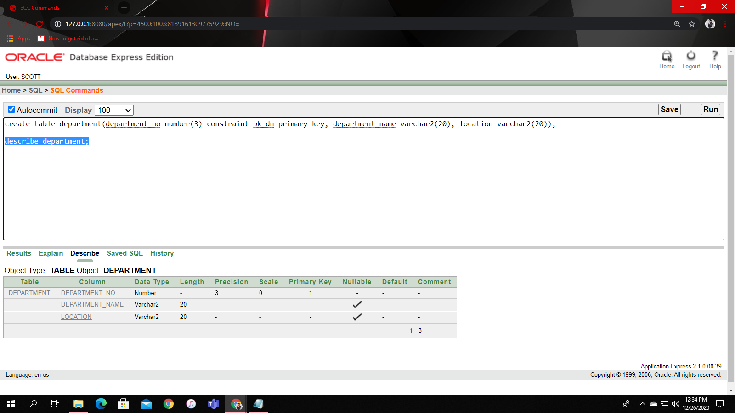

2th: Ward table:

create table ward(ward_no number(3) constraint pk_wn primary key, ward_type varchar2(20), ward_section varchar2(20), department_name varchar2(20));

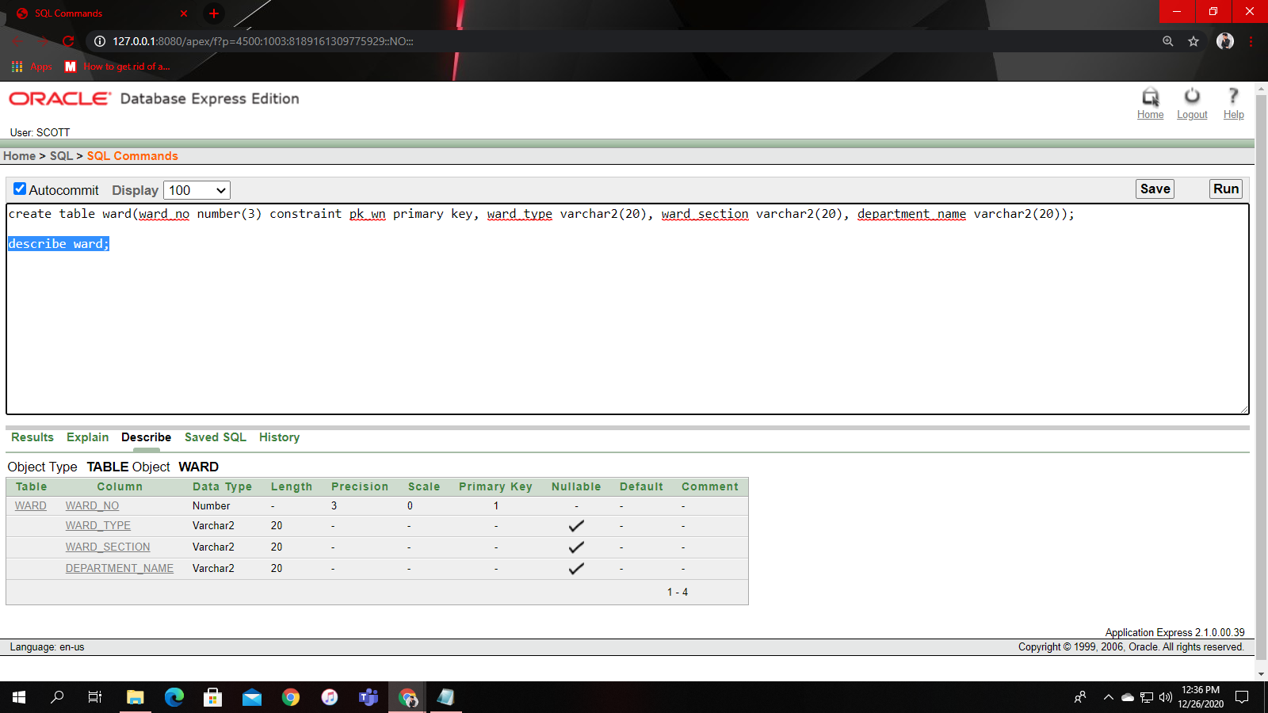

3nd: Employee table:

create table employee(employee_id number(3) constraint pk_ei primary key, first_name varchar2(20), last_name varchar2(20), post varchar2(20), sector varchar2(20), employee_ward_no number(3), employee_ward_section varchar2(6), department varchar(20), constraint fk_ei foreign key (employee_ward_no) references ward(ward_no));

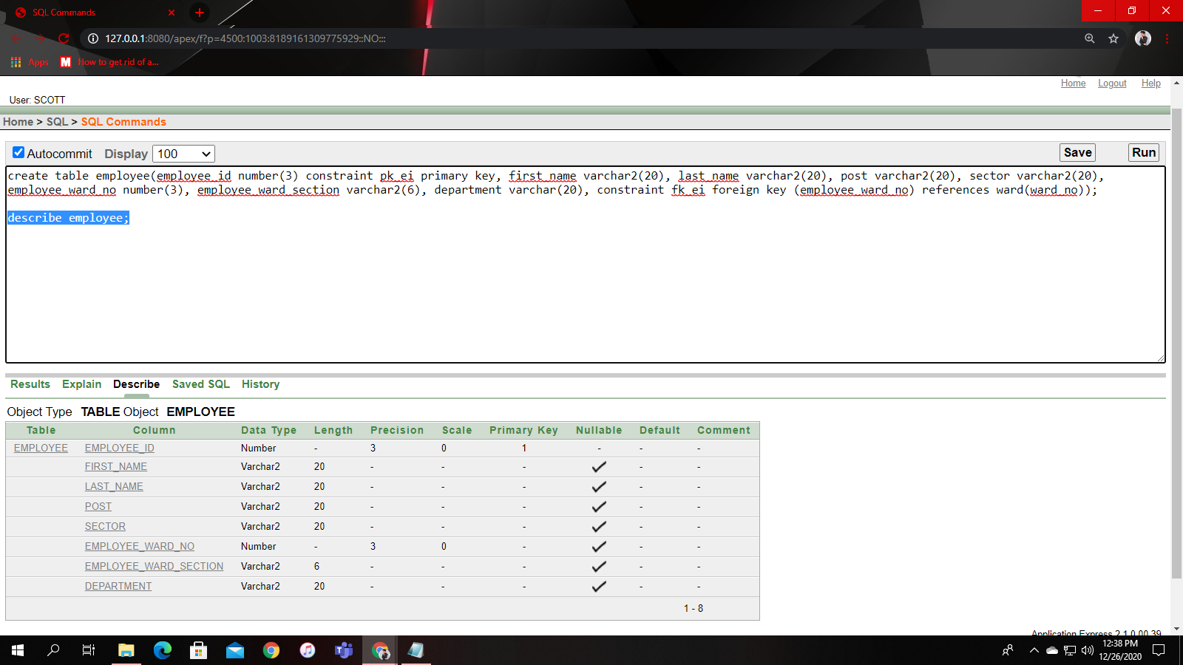

4rd: Laboratory table:

create table laboratory(laboratory_no number(3) constraint pk_ln primary key, laboratory_type varchar2(20), department_name varchar2(20));

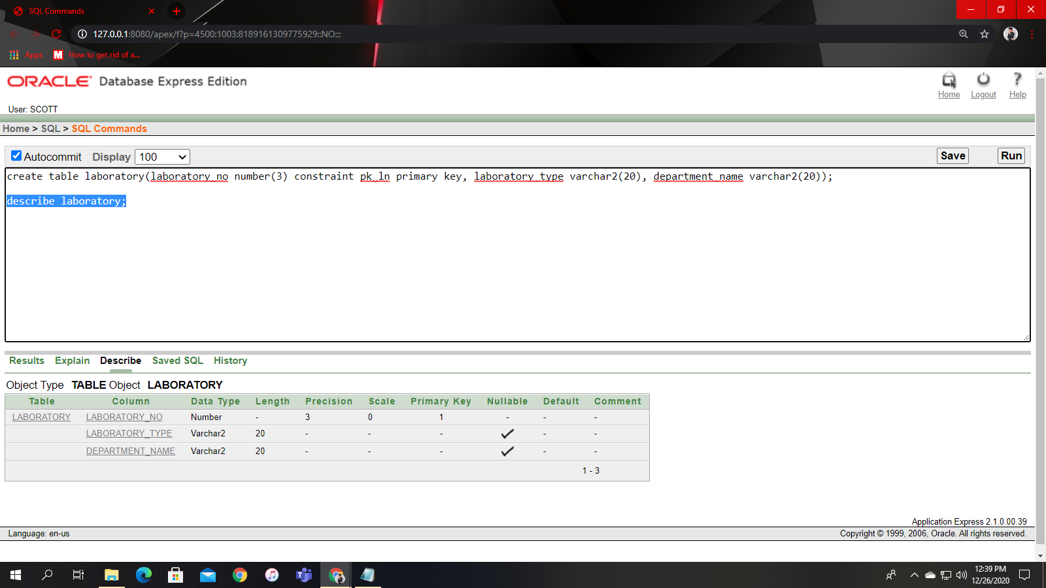

5th: Salary table:

create table salary(salary_grade number(3) constraint pk_sg primary key, highest_salary number(6), lowest_salary number(6), department_name varchar2(20));

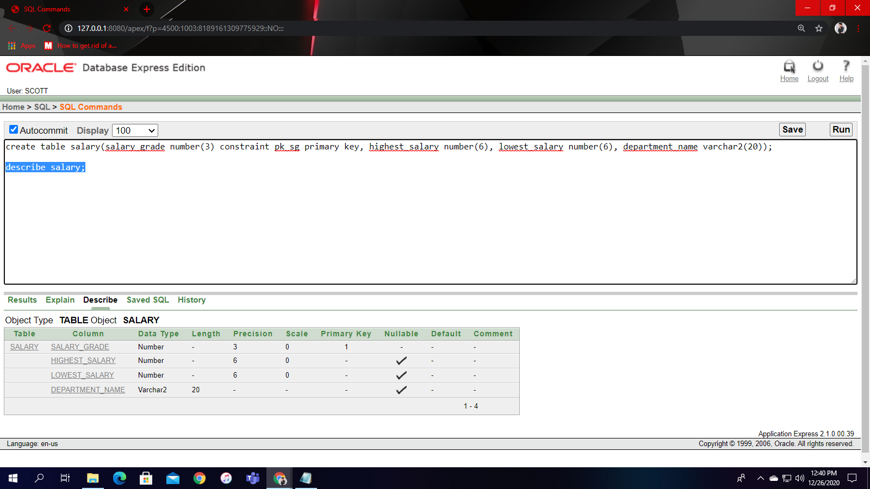

6th: Patient table:

create table patient(patient_id number(3) constraint pk_pi primary key, patient_name varchar2(20), patient_ward_no number(3), mobile_no number, date_of_birth date, age number(2), gender varchar2(6), address varchar2(50), constraint fk_pi foreign key (patient_ward_no) references ward(ward_no));

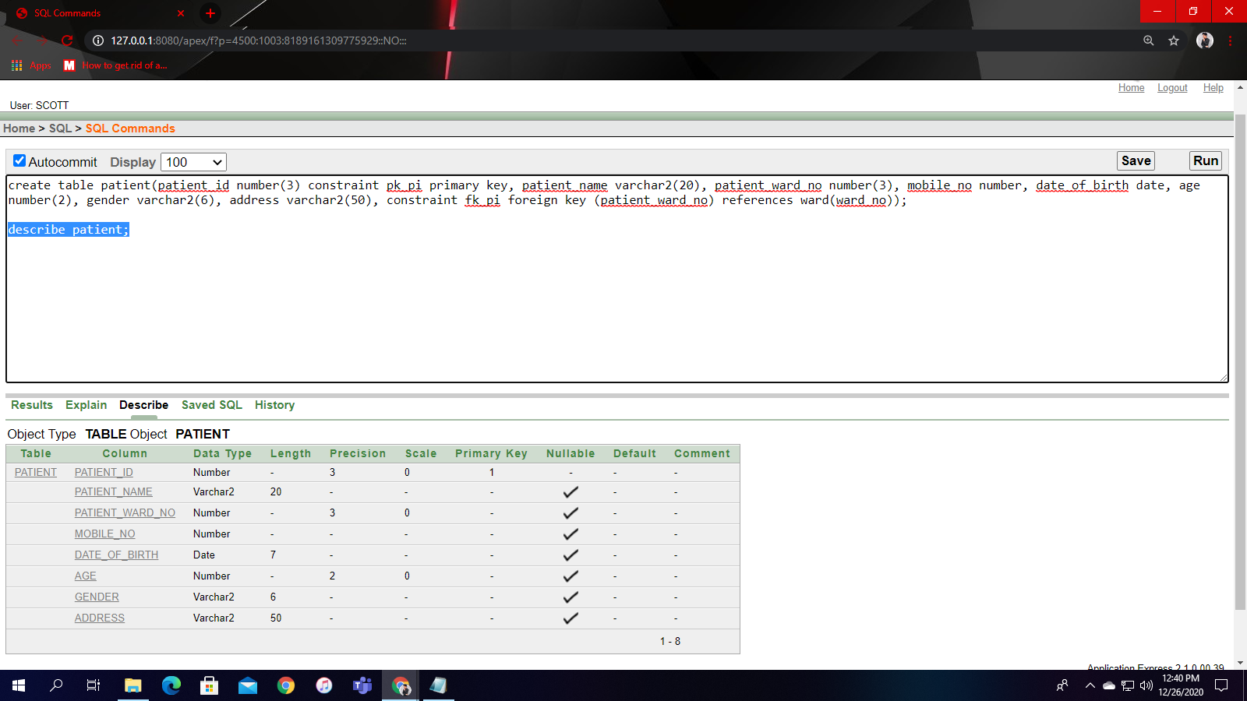

7th: Payment table:

create table payment(payment_no number(3) constraint pk_pn primary key, payment_date date, payment_amount number(6), department_name varchar2(20));

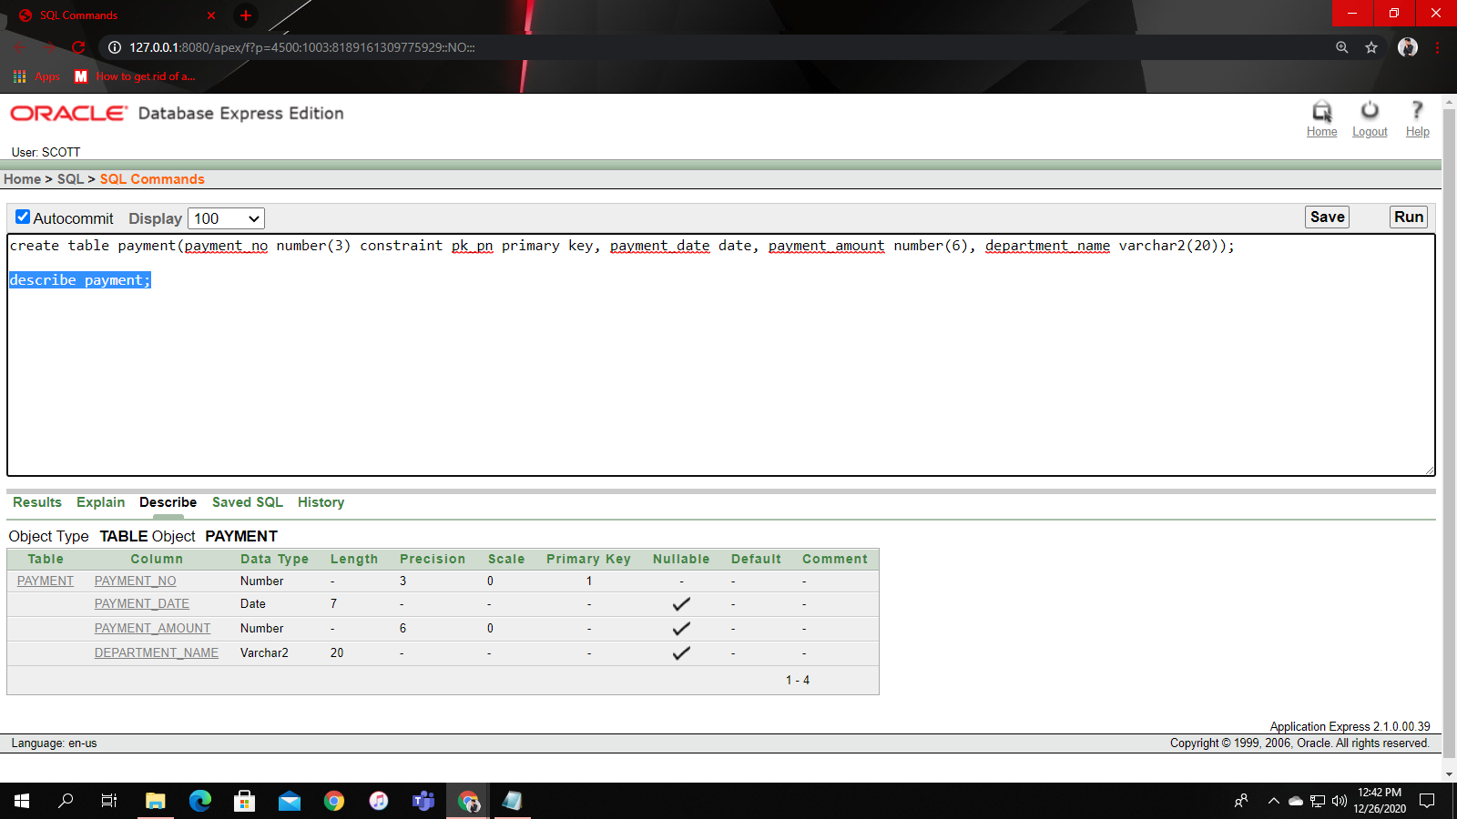

8th: Account table:

create table account(account_no number(3) constraint pk_an primary key, add_or_less number(6), amount number(6), account_type varchar2(20), department_name varchar2(20));

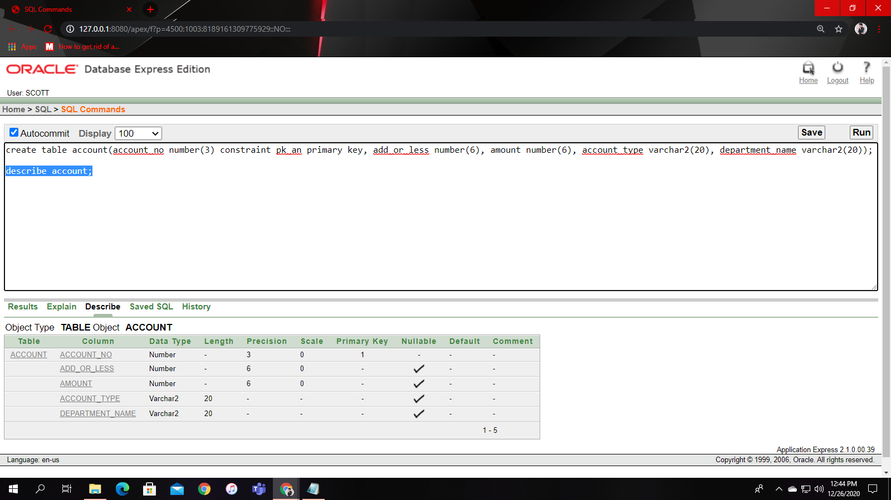

**Data insertion:**

1.

insert into department values(1, 'Outpatient', 'With entrance');

insert into department values(2, 'Inpatient Service', '2nd floor');

insert into department values(3, 'Pharmacy', 'Beside OPD');

select * from department;

2.

insert into ward values(1, 'Beds', 'A', 'Inpatient Service');

insert into ward values(2, 'ICU', 'B', 'Inpatient Service');

insert into ward values(3, 'Operating theatre', 'C', 'Inpatient Service');

select * from ward;

3.

insert into employee values(1, 'David', 'Williams', 'Doctor', 'Surgeon', 3, 'C', 'Inpatient Service');

insert into employee values(2, 'James', 'Rodriguez', 'Doctor', 'Medical technologist', 2, 'B', 'Inpatient Service');

insert into employee values(3, 'Maria', 'Garcia', 'Nurse', 'Registered nurse', 1, 'A', 'Inpatient Service');

select * from employee;

4.

insert into laboratory values(1, 'Hematology', 'Inpatient Service');

insert into laboratory values(2, 'Chemistry', 'Pharmacy');

insert into laboratory values(3, 'Microbiology', 'Pharmacy');

select * from laboratory;

5.

insert into salary values(1, 10000, 4000, 'Pharmacy');

insert into salary values(2, 20000, 10001, 'Outpatient');

insert into salary values(3, 30000, 20001, 'Inpatient Service');

select * from salary;

6.

insert into patient values(1, 'James', 2, 01687499999, '25-MAR-01', 19, 'Male', '123 Main Street, New York, NY 10030');

insert into patient values(2, 'Michael', 1, 01715704035, '15-JUL-04', 15, 'Male', 'Celeste Slater 606-3727 Ullamcorper. Street');

insert into patient values(3, 'Jenifer', 1, 01300666180, '19-JUN-02', 18, 'Female', 'Theodore Lowe Ap #867-859 Sit Rd. Azusa');

select * from patient;

7.

insert into payment values(1, '24-DEC-20', 4500, 'Pharmacy');

insert into payment values(2, '25-DEC-20', 10500, 'Outpatient');

insert into payment values(3, '26-DEC-20', 20500, 'Inpatient Service');

select * from payment;

8.

insert into account values(1, 500, 26000, 'Patient account', 'Inpatient Service');

insert into account values(2, 100, 18000, 'Patient account', 'Outpatient');

insert into account values(3, 2000, 27000, 'Employee account', 'Inpatient Service');

select * from account;

**Joining:**

Equijoin: 1

select * from employee, ward where employee_ward_no=ward_no;

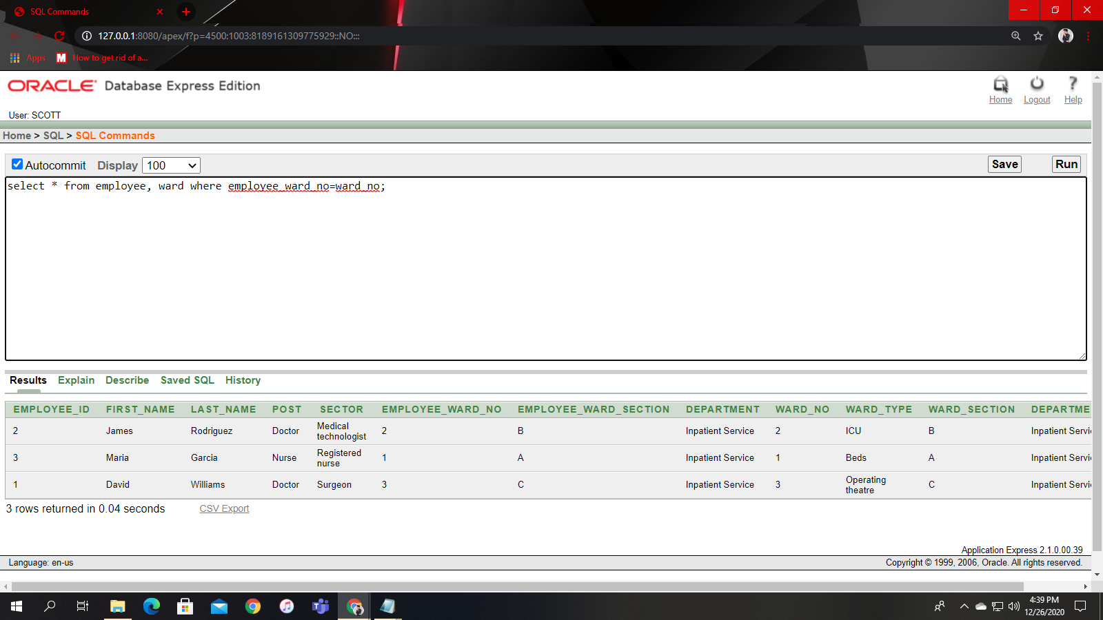

Equijoin: 2

select * from patient, ward where patient_ward_no=ward_no;

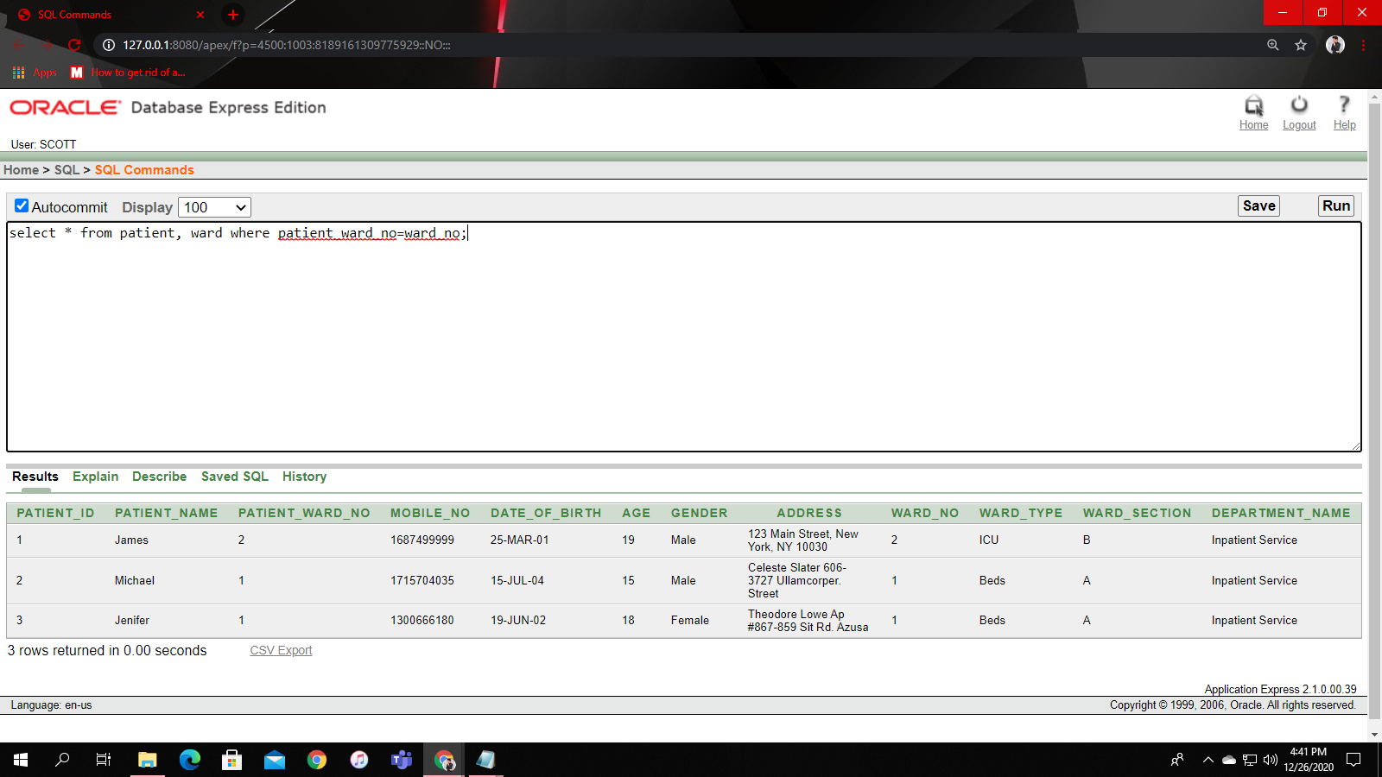

Outer join: 1

select * from patient, ward where patient_ward_no(+)=ward_no;

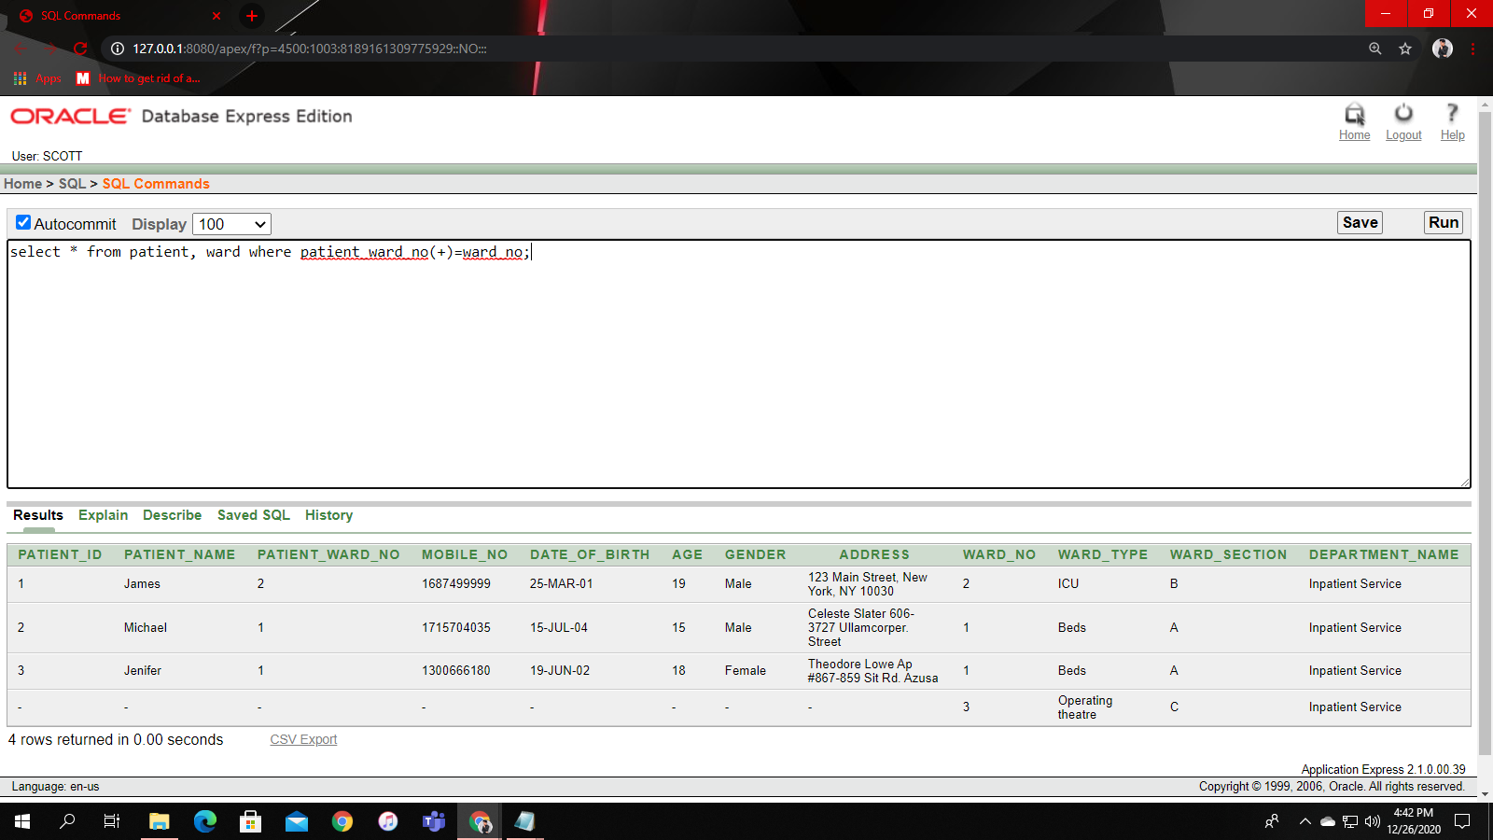

Self-join: 1

select * from employee e1, employee e2 where e1.employee_id=e2.employee_ward_no;

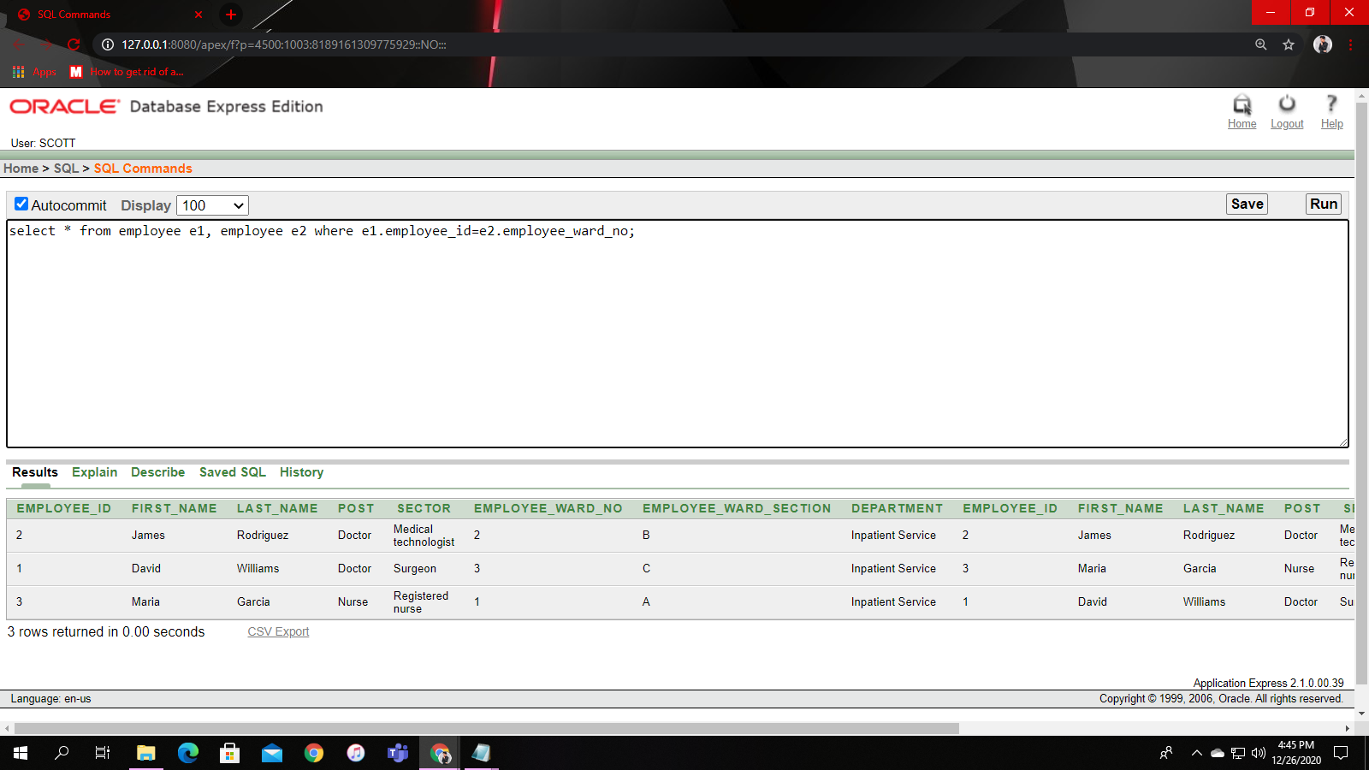

**Subquery:**

Without group function:

Q1. Show first name and last name of all employees who works in operating theatre.

Sol: select first_name, last_name from employee where employee_ward_no=(select ward_no from ward where ward_type='Operating theatre');

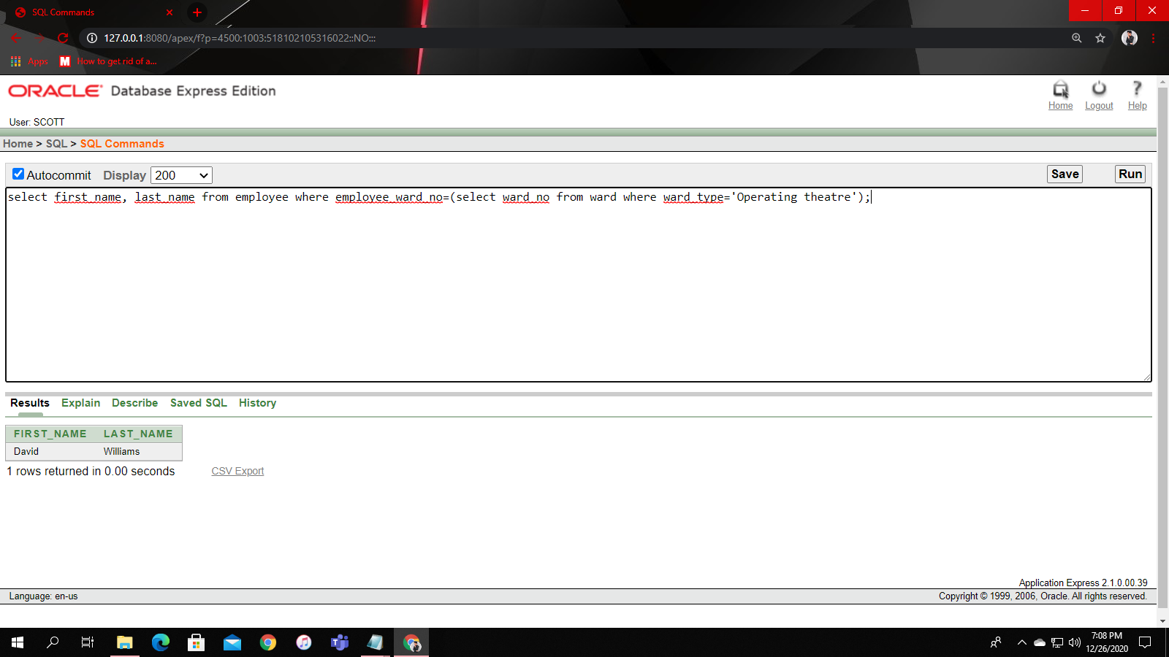

Q2. Show all patients who are in beds.

Sol: select * from patient where patient_ward_no=(select ward_no from ward where ward_type='Beds');

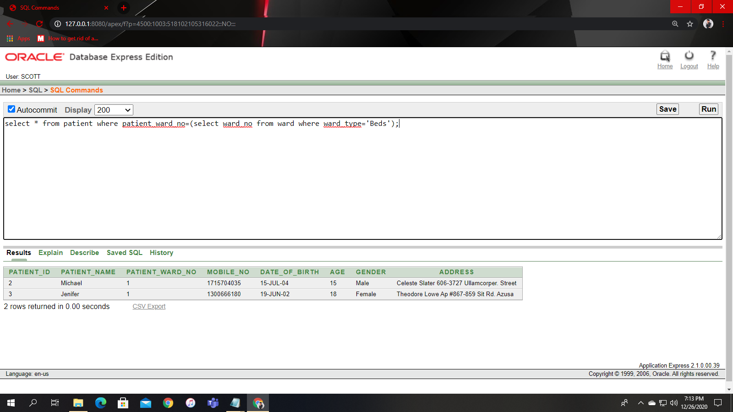

With group function:

Q3. Display all the patients whose age are below less than the average age of all patients.

Sol: select * from patient where age<(select avg(age) from patient);

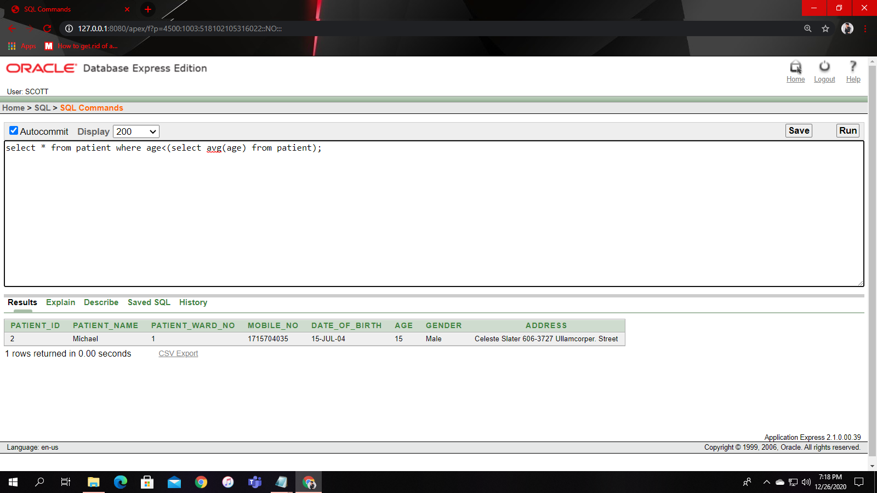

Q4. Show the name of department which recerives lowest salary.

Sol: select department_name from salary where lowest_salary=(select min(lowest_salary) from salary);

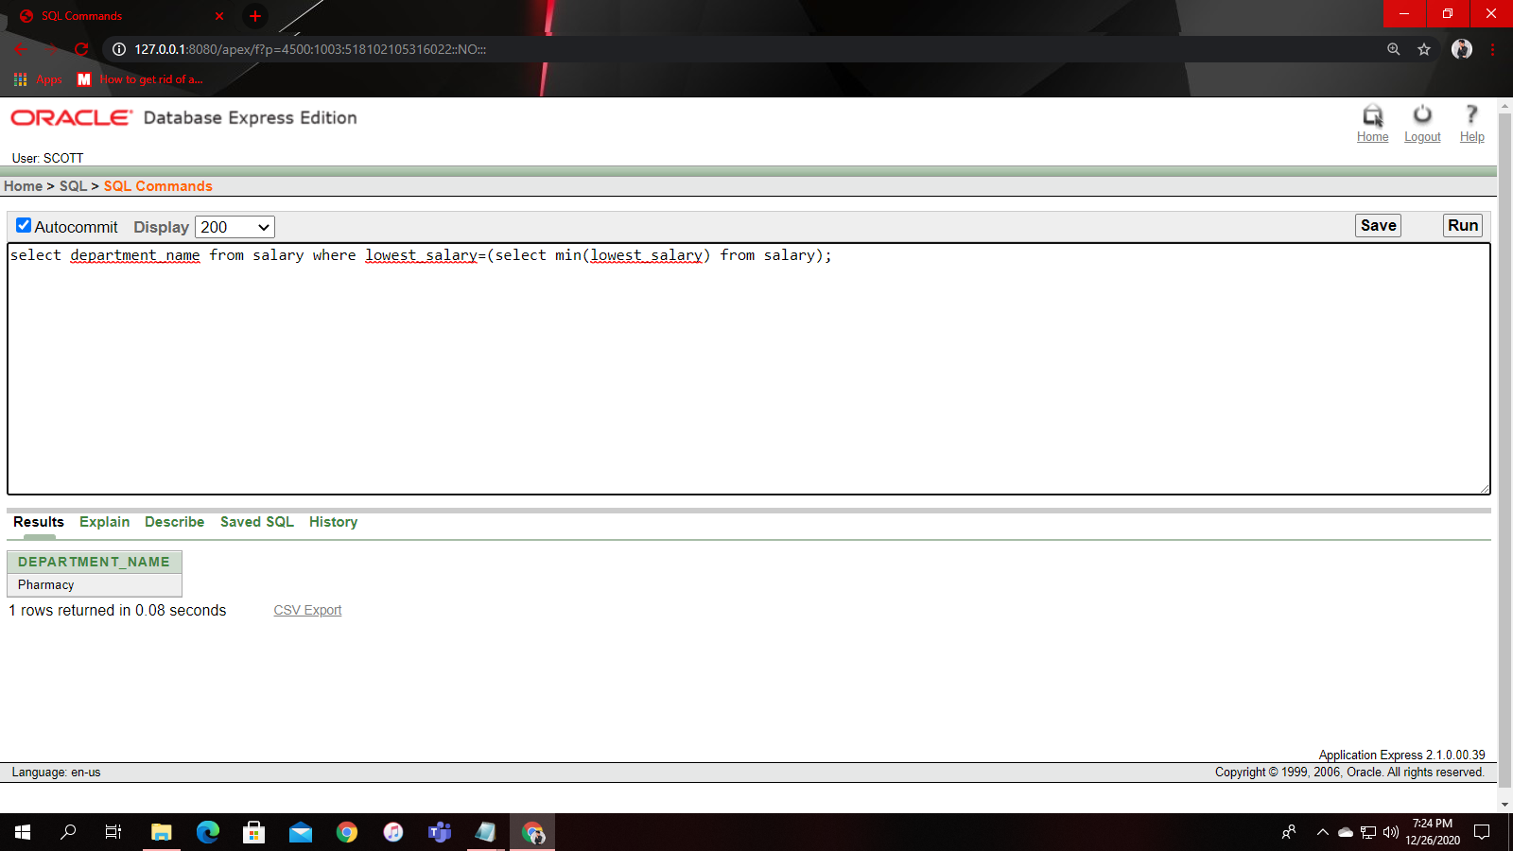

**View:**

Simple:

create view labvu as select laboratory_type from laboratory where department_name='Pharmacy';

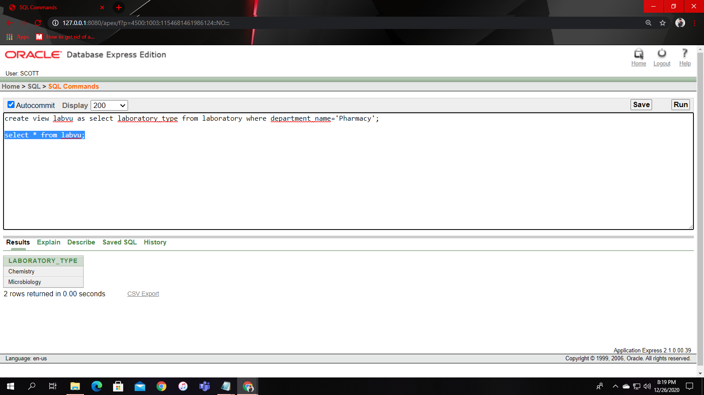

Complex:

create view patvu ("Name", "Mobile number", "Address", "Ward type", "Ward Section") as select p.patient_name, p.mobile_no, p.address, w.ward_type, w.ward_section from patient p, ward w where p.patient_ward_no=w.ward_no;

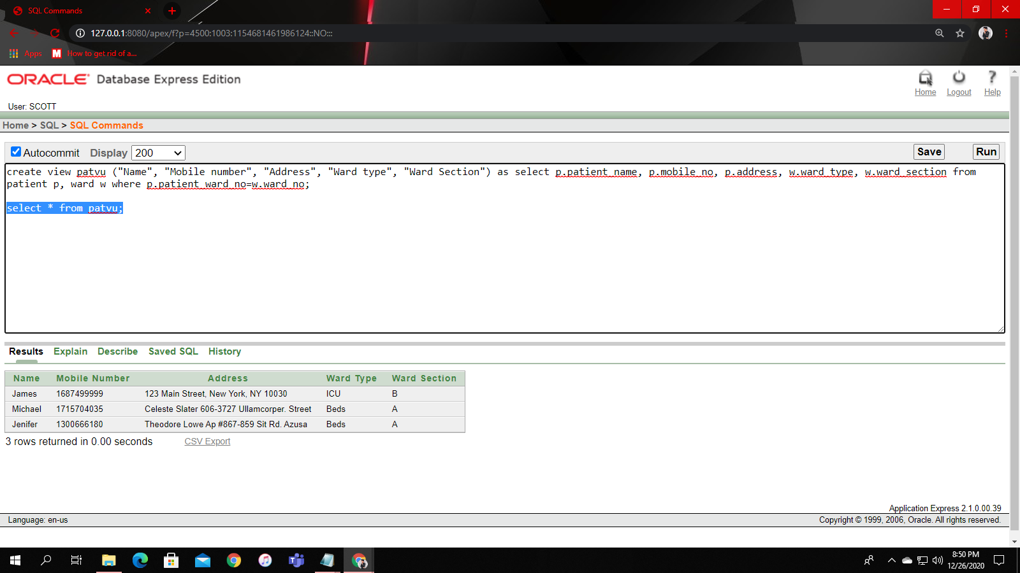

**Add constraint:**

alter table payment modify payment_amount default(0);

